Guide 2. APT Project Development
Capstone Course

Personal Information
Below is a table where you must complete the requested information.

Student Name | National ID (RUT) | Degree Program | Campus
Lucas Joaquin Carvajal Pincheira | 21.146.055-5 | Computer Science & Software Engineering (Ingeniería en Informática) | Viña del Mar
Osvaldo Antonio Reyes Wiegand | 19.336.327-k | Computer Science & Software Engineering (Ingeniería en Informática) | Viña del Mar

1. APT Project Progress Summary
Below you will find various fields that you must complete with the requested information.

APT Project Progress Summary | During this stage, progress focused primarily on consolidating the data infrastructure and analytical baseline of the Predictive Demand and Inventory Optimization System for the wholesale apparel and footwear distributor in the Valparaíso Region (Quilpué / Viña del Mar). Based on an initial transactional extract provided by the client—which was expanded by the company itself according to its actual business operations to reach 1,000 records—an automated Extraction, Transformation, and Loading (ETL) pipeline was successfully implemented in Python using Pandas, filtering out null values and correcting inconsistencies. Additionally, a containerized Microsoft SQL Server 2022 relational database engine was deployed via Docker Compose on port 1434 with persistent storage volumes, where the cleaned data was fully loaded using SQLAlchemy. Finally, the initial Machine Learning predictive model (Random Forest Regressor) was trained, achieving a baseline Mean Absolute Error (MAE) of 24.11 units, and the layout of the executive web dashboard in Streamlit was developed for early inventory alert visualization by the client.
Objectives | - Develop a predictive software system based on Machine Learning to optimize inventory management and estimate future product demand in a textile and footwear wholesale company.  - Implement an automated data ingestion, cleaning, and normalization pipeline (ETL) in Python to ensure the integrity of sales records.  - Deploy and configure the relational/dimensional database in Microsoft SQL Server 2022 using Docker containers to guarantee persistence and centralization of transactional information.  - Train and evaluate Machine Learning models (Random Forest / Time Series) using formal quantitative metrics (MAE/MAPE) to project seasonal purchasing volume.  - Build an interactive web interface in Streamlit that allows the wholesale company user to visualize sales reports, demand forecasts, and preventive stockout alerts.
Methodology | The project continued to be developed under the Agile Scrum framework, adapted to the academic context through iterative and incremental deliveries oriented toward data architecture and applied artificial intelligence. The agile ceremonies and guidelines defined by the team were maintained:  - Sprint Planning and Daily Meetings: Planning sessions were held at the beginning of each cycle along with remote synchronization meetings (2 to 3 times per week) to coordinate workloads across technical roles (Osvaldo Reyes in database architecture, ETL, and Machine Learning algorithms; Lucas Carvajal in requirements engineering, documentation quality assurance, test design, and KPI calculation).  - Sprint Review and Retrospective: At the end of each cycle, functional technical increments were reviewed (ETL scripts, Docker orchestration, SQL Server migration scripts, and AI training console), analyzing facilitators and blockers (such as unstructured historical client data and credential management) and agreeing on versioning and security improvements.  - Technical work relied on Visual Studio Code, Python (Pandas, Scikit-Learn, SQLAlchemy, PyODBC), Microsoft SQL Server 2022 containerized on Docker Desktop, and Streamlit for the presentation layer. Unit tests, integration tests, and quantitative metrics were applied to back software quality.
Progress Evidence | The presented evidence corresponds to the deliverables committed in the formal Phase 1 document (1.5) and the software quality assurance guidelines:  - 1. ETL Pipeline and Persistence Model (Milestone 2 / Progress 1): Execution of the Python script (archivo.py) to clean the client's database records and export them to ventas_limpio_sql.csv (950 records with 100% integrity), followed by the bulk migration script (cargar_bd.py) connected to SQL Server.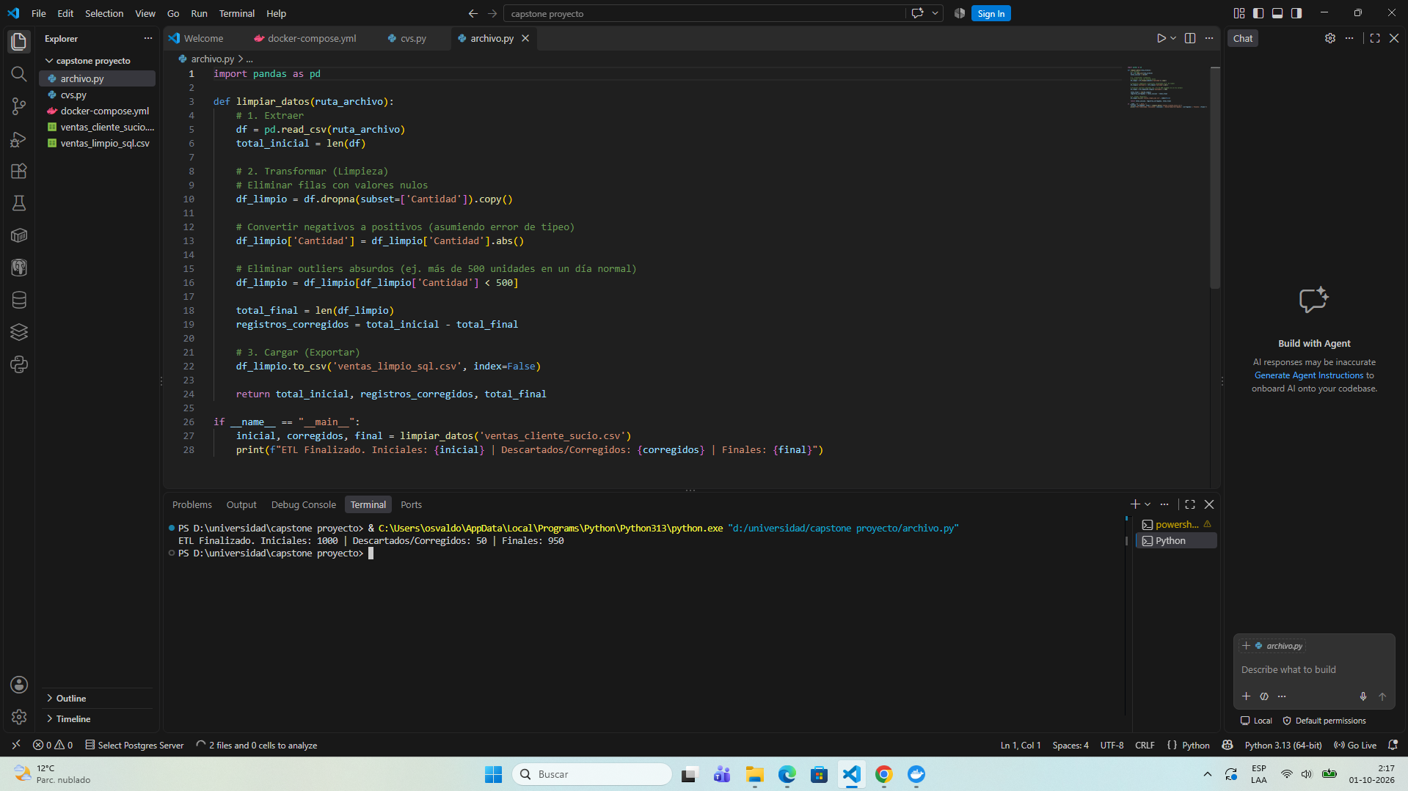  - 2. Containerized Infrastructure: Orchestration file docker-compose.yml running the sqlserver service (image mssql/server:2022-latest, container bd_capstone_sql on port 1434 with persistent volume sqlserver_data).  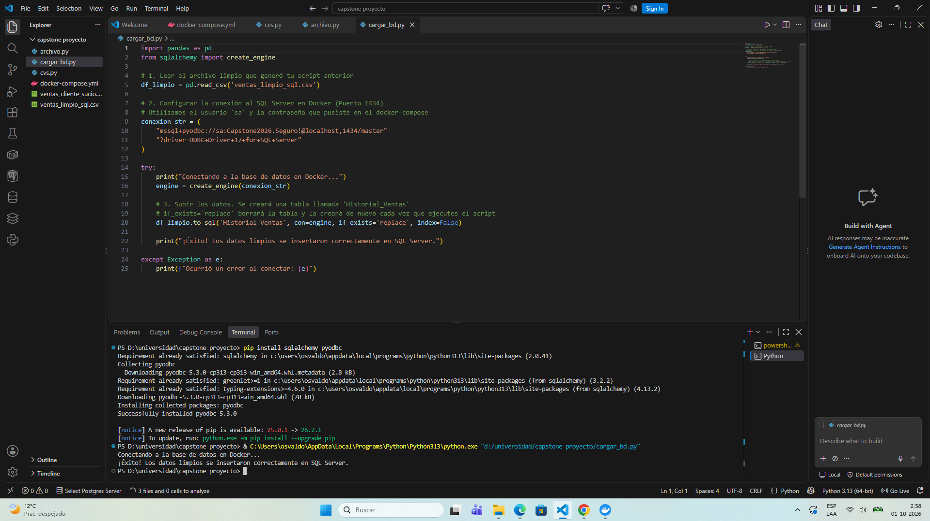  - 3. Artificial Intelligence Predictive Engine (Milestone 3): Machine Learning training source code (Random Forest in entrenamiento_ml.py) executed with an 80/20 train/test split, yielding a console-measured Mean Absolute Error (MAE) of 24.11 units per garment as a seasonal inference baseline.  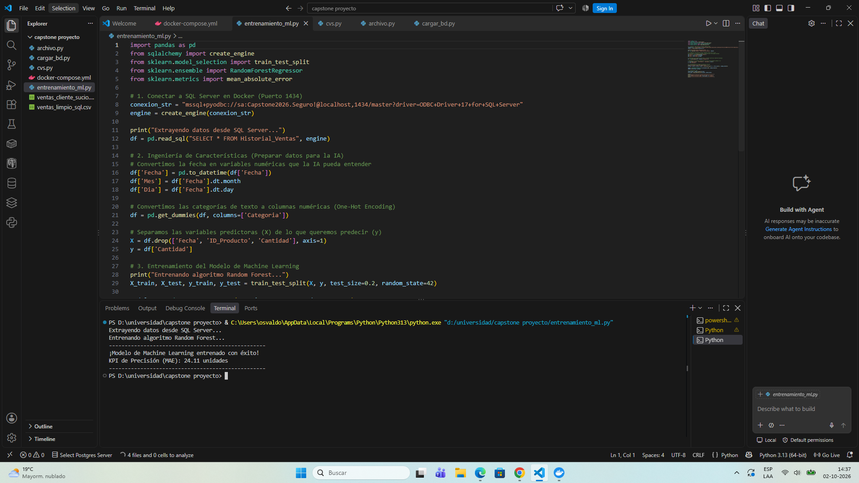  - 4. Unit and Integration Test Cases: Formal execution of tests PU-01 (dropna), PU-02 (abs), PI-01 (ETL + CSV), and PI-02 (Python + Docker SQL Server) with Approved status.  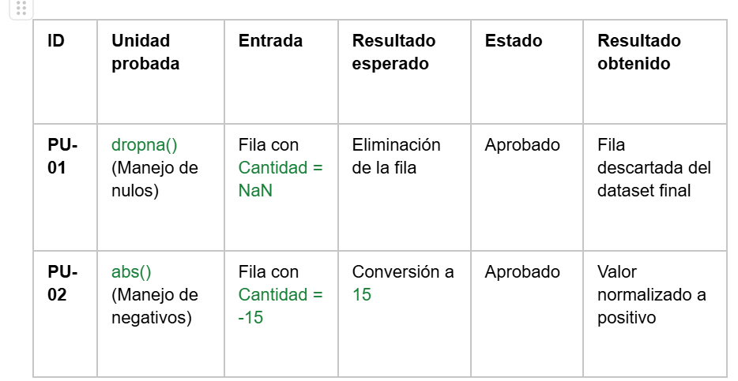  - 5. Technical Metrics and KPIs: Formal registration of KPI-01 (Ingestion Quality: 100% of data processed with no anomalous values) and KPI-02 (Predictive Model Precision: baseline MAE of 24.11 units).  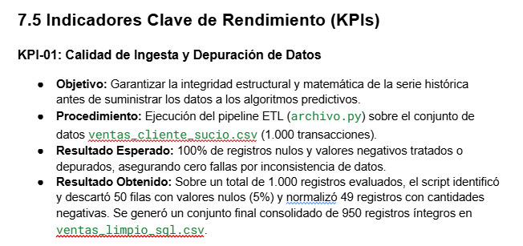  6. Backlog and Dashboard: Local deployment in Streamlit (app.py) featuring graphical visualization of historical sales by category and an inventory control panel.  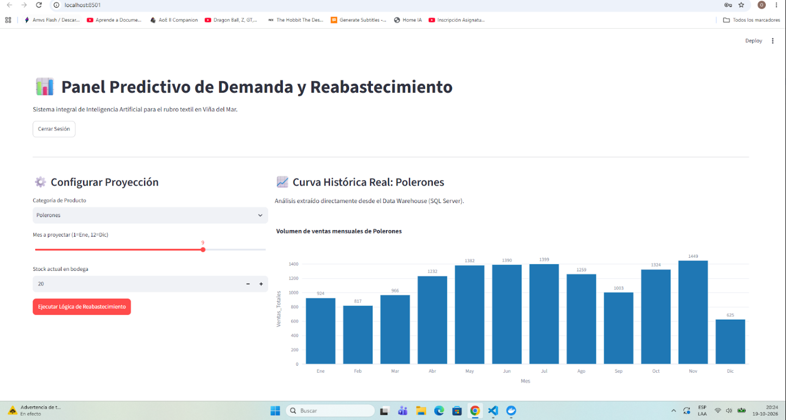  7. Login Security: Implementation of a secure login interface (Secure Access - Wholesale Panel) with credential authentication for users and administrators.  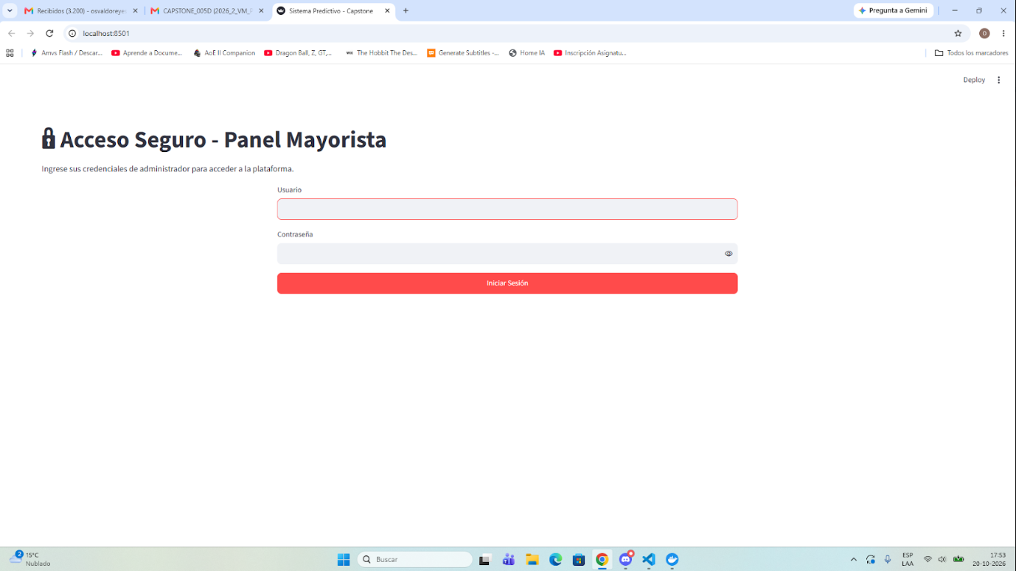  8. Predictive API: Construction and documentation in FastAPI (Swagger UI) of the /calcular_compras/ endpoint for communication between the AI model and the backend.  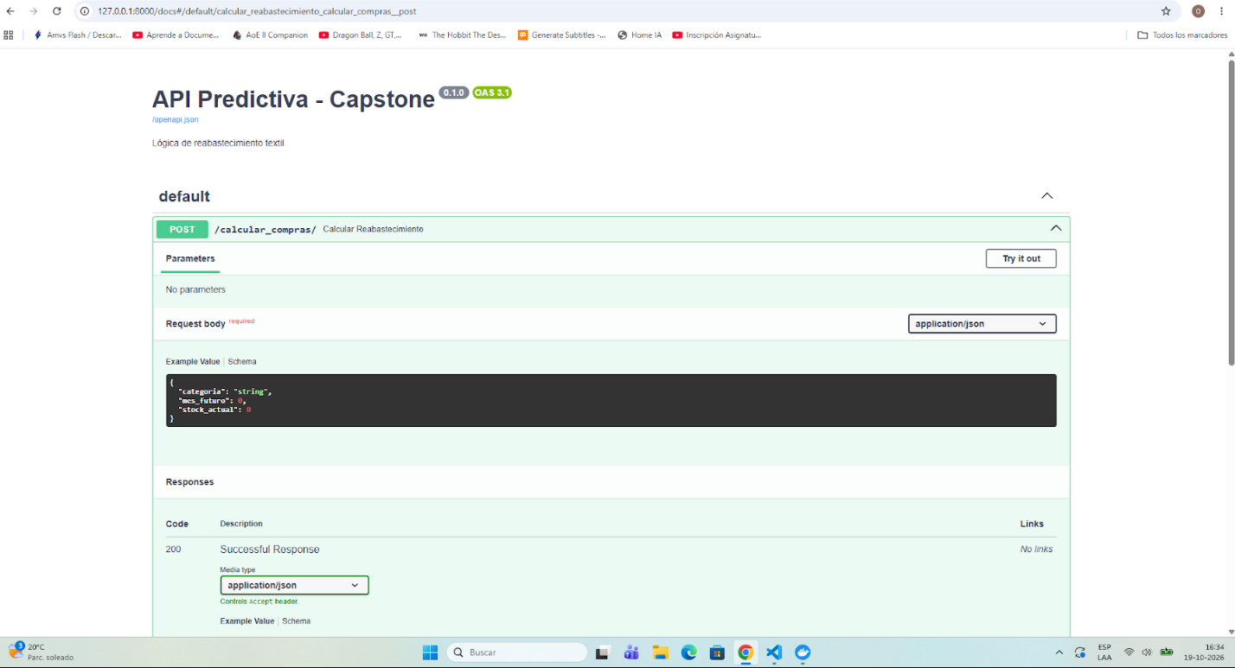  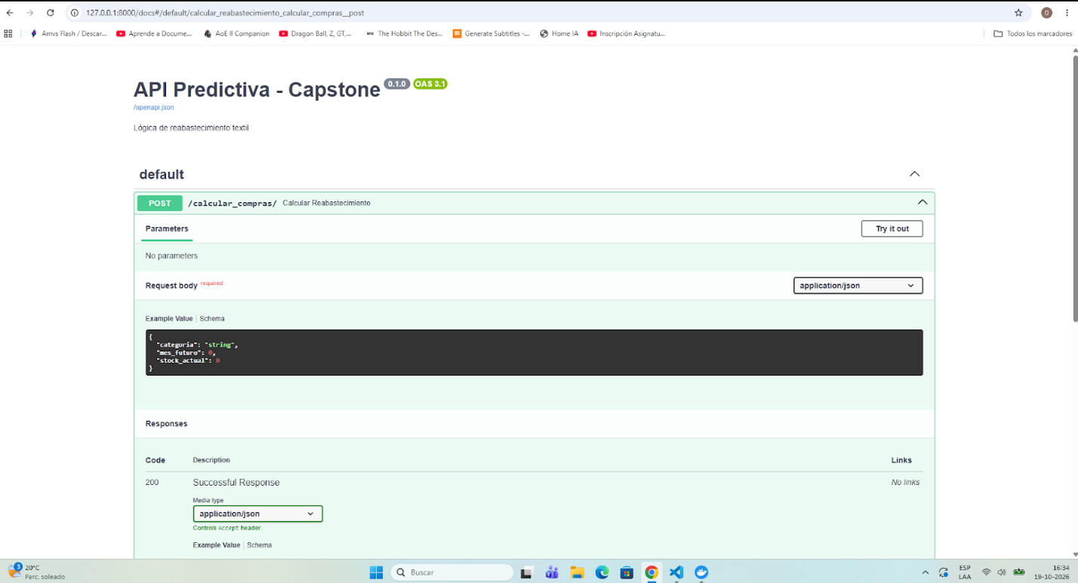  9. Interactive Predictive System: Interactive frontend module for warehouse stock input, monthly demand projection, and automatic alert calculation for critical stock.  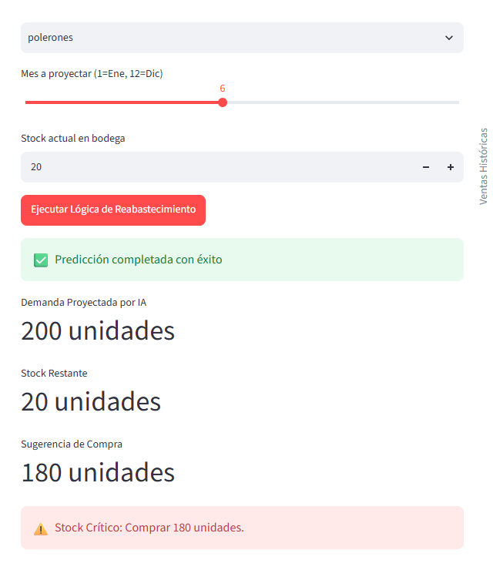

2. Work Plan Monitoring
Carefully examine your work plan, focusing especially on the progress status and adjustments columns.

APT Project Work Plan
Competency or Competency Units | Activities | Resources | Activity Duration | Responsible | Observations / Remarks | Progress Status | Adjustments
Requirements Engineering | Phase 1: Requirements gathering and definition of inventory variables | Virtual/in-person meeting with client, Text documents | 1 week | Lucas Carvajal | Clarity on wholesale purchasing challenges; the obstacle was the lack of formal structure in the client's historical records | Completed | No adjustments made
Agile Management (Scrum) | Phase 1: Role definition, Product Vision, and prioritized Backlog | Scrum templates, Visual Studio Code | 1 week | Lucas Carvajal and Osvaldo Reyes | Facilitated an equitable division between data/AI engineering and documentation QA; the obstacle was coordinating delivery schedules | Completed | No adjustments made
Data Architecture and Management | Phase 1: Architecture definition, persistence strategy, and Docker setup | Docker Desktop, docker-compose.yml | 2 weeks | Osvaldo Reyes | Containerization guaranteed immediate portability; the obstacle was the local port 1433 conflict | Completed | No adjustments made
Data Engineering (ETL) | Phase 2 - Sprint 1: Client data ingestion and ETL cleaning pipeline | Python, Pandas, Visual Studio Code | 2 weeks | Osvaldo Reyes | A real data extract was requested from the company; since the initial sample was small, the client expanded it with additional rows aligned with their actual business operations | Completed | Consolidation and cleaning of the 1,000-row dataset provided and expanded by the client
Relational Databases | Phase 2 - Sprint 1: Migration and bulk insertion into Docker SQL Server | SQLAlchemy, PyODBC, Docker Container | 1 week | Osvaldo Reyes | Robust connection without record loss; the obstacle was ODBC driver compatibility in the operating system | Completed | No adjustments made
Artificial Intelligence | Phase 2 - Sprint 2: Baseline predictive model training and MAE calculation | Python, Scikit-Learn (Random Forest), VS Code | 2 weeks | Osvaldo Reyes | Fast computation of the tree ensemble; the challenge was balancing the 80/20 validation split | Completed | No adjustments made
QA / Testing and Quality | Phase 2: Unit tests, integration tests, and KPI formalization | Testing scripts, VS Code Terminal | 2 weeks | Lucas Carvajal | Tests PU-01 to PI-02 approved; the challenge was capturing exact execution times and metrics in console | Completed | KPI-01 and KPI-02 technical sheets were formalized
Frontend / UI Development | Phase 2 - Sprint 3: Dashboard layout and alert module | Streamlit, Python, Visual Studio Code | 2 weeks | Osvaldo Reyes and Lucas Carvajal | Streamlit enables rapid development in Python; the challenge was connecting the replenishment logic with the charts | Completed | Visual components developed and integrated
Software Security | Phase 2: Environment variable management and network isolation | .env, .env.example, .gitignore files | 1 week | Lucas Carvajal | Isolates credentials from the repository; the challenge was removing plaintext passwords from legacy scripts | Completed | Passwords decoupled into .env file
Technical Documentation | Phase 2: Consolidation of Phase 2 report, technical manual, and README | Word, Markdown, Architecture Diagrams | 1 week | Lucas Carvajal | Complete backing of evidence; the challenge is the time required to diagram the end-to-end architecture | Completed | No adjustments made

3. Adjustments Based on Monitoring
Delve into the observations of your work plan. Analyze the planned activities and indicate which aspects facilitated or hindered the execution of the plan. Explain how you addressed and/or will address the obstacles. Finally, state the adjustments made to the work plan based on this analysis.

Factors that have facilitated and/or hindered the development of the work plan:
Facilitating Factors:
The strict division of roles and disciplinary responsibilities between team members (Osvaldo Reyes in technical architecture, script development, and algorithmic modeling; and Lucas Carvajal in requirements management, test case design, and documentation QA). Furthermore, using modern tools like Docker Desktop allowed rapid deployment of a standardized and reproducible SQL Server 2022 database engine, reducing local software configuration times.
Obstructing Factors:
The integration of Microsoft SQL Server via Docker Desktop represented an initial technical challenge in the project's data architecture. Initially, the transition hindered progress due to network conflicts with the default port (1433) and compatibility issues with ODBC drivers in the local environment. However, this obstacle was overcome by reconfiguring the Docker Compose orchestration to external port 1434 and adjusting the connection strings using SQLAlchemy and PyODBC in Python, ultimately guaranteeing data persistence, isolation, and portability.
Client Dataset Consolidation and Expansion: Upon requesting the sales history, the wholesale company initially provided a small-volume data extract. To reach the optimal volume for Machine Learning training (1,000 records), the client directly expanded the spreadsheet by adding extra rows based on their actual commercial behavior and operational business parameters across the 4 product categories.

Adjusted or Removed Activities:
Database Port Reconfiguration: The network configuration in the docker-compose.yml file was adjusted to bind the service through port 1434:1433, adapting the Python scripts' connection string to localhost,1434 without altering container integrity.
No Activities Removed: All tasks associated with software engineering, data architecture, Machine Learning model development, and user interface development remain active within the project scope.

Activities Not Started or Delayed: According to the schedule established in Document 1.5 from Phase 1, we are ahead of schedule regarding the joint work of Phase 2. In-progress activities are minimal, the system is functional and requires only minor refinements, data ingestion has been completed, and final documentation is currently in progress.

Critical infrastructure activities, ETL cleaning pipelines, SQL Server loading, Machine Learning training, and unit/integration testing are 100% completed.
Tasks currently in progress include final refinements to the Streamlit web interface (app.py) for inventory alert deployment, drafting the technical manual, and consolidating the official report.
The activity that has not yet started corresponds to Phase 3: Final user stress testing, field operational validation, and the formal Capstone Portfolio defense before the evaluation committee.

- Breiman, L. (2001). Random forests. Machine Learning, 45(1), 5–32. https://doi.org/10.1023/A:1010933404324
- Kimball, R., & Ross, M. (2013). The data warehouse toolkit: The definitive guide to dimensional modeling (3.ª ed.). John Wiley & Sons.
- McKinney, W. (2022). Python for data analysis: Data wrangling with pandas, NumPy, and Jupyter (3.ª ed.). O'Reilly Media.
- Schwaber, K., & Sutherland, J. (2020). La Guía de Scrum: La guía definitiva de Scrum: Las reglas del juego. Scrum.org. https://scrumguides.org/

